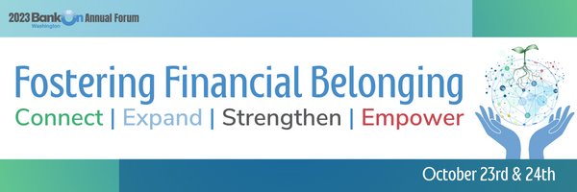

Participants will have the opportunity to select one of 5 areas of focus and will join an Action Squad learning group to process and discuss the content together during the 2-day event. The focus areas are youth, immigrants & refugees, justice-involved individuals, microenterprise, and black homeownership initiative. We are leaning into creating even more space for networking and interaction, balancing content provided from the front of the room and expertise shared from the whole community. And we are excited to offer the opportunity to dive deeper into what financial inclusion and financial belonging means in the context of work in these areas.

We have identified the following outcomes for each of our Action Squads:

Youth Action Squad:
- Understand common barriers faced by BIPOC youth to equitably access financial resources and tools.
- Identify methods for BIPOC youth to safeguard their financial wellbeing.
- Identify resources to adapt into their services and build referral networks.

Black Homeownership Action Squad:
- Know about initiatives across Washington focused on Black homeownership
- Identify organizations increasing the supply of affordable homes
- Identify barriers to becoming mortgage-ready for Black families
- Be willing to engage with initiatives in their service area

Microenterprise Action Squad:
- Understand how the 5 C’s of Credit inform lending options
- Identify common barriers to starting or growing microenterprise opportunities
- Identify methods of advocating for micro entrepreneurs in finding the right lender

Immigrant & Refugee Action Squad:
- Understand common barriers to financial systems faced by immigrants & refugees
- Identify avenues of collaboration between Community-Based Orgs and Financial Institutions in serving immigrants & refugees

Justice-Involved Action Squad:
- Understand the barriers faced by people who have been Justice-involved
- Learn about current resources for people who have been Justice-Involved
- Connect with colleagues to discuss intersections with their work.

